**THE UNITED REPUBLIC OF TANZANIA**

**EASTERN AFRICA STATISTICAL TRAINING CENTRE**

**(EASTC)**

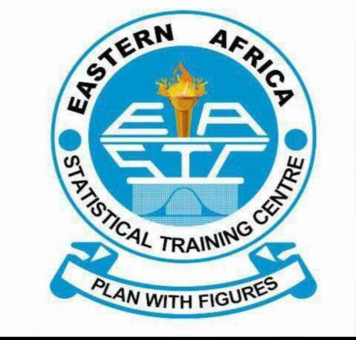

**MODULE: WEB DESIGN and DEVELOPMENT**

**MODULE CODE: DSU07209**

**TASK: INDIVIDUAL ASSIGNMENT**

**LECTURER: Mr. ELIAH KAZUMALI**

**NAME: KAIZA EMILIAN KARUGENDO**

**REG NO: EASTC/BDTS/24/01531**